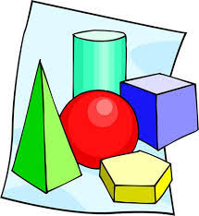
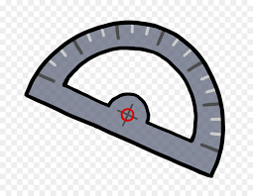
Maths Scavenger Hunt
Shape and Space Strand
5th and 6th class

Glossary:
- Parallel lines are straight lines that are always the same distance from one another. They will never meet.

- An acute angle is less than 90 degrees and an obtuse angle is more than 90 degrees.

- A right angle is exactly 90 degrees.

- A polygon is a 2D shape formed with straight sides. A regular polygon is a 2D Shape whose sides are all the same length and whose angles are all the same size. A cube is a regular polygon.

- An irregular polygon has one or more sides longer that the other sides.

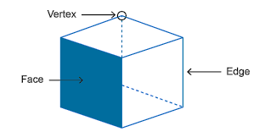
- A 3D shapes has a face, vertex (vertices if more than one) and an edge.

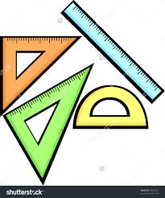
Task 1: Lines and Angles

- Find and name examples of each of these shapes in or outside your house:
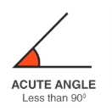
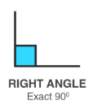
- An acute angle __________________
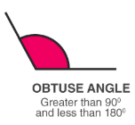
- A right angle __________________
- An obtuse angle __________________
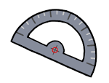
- A straight angle __________________
- Create a 90 degree and a 45 degree angle using objects you find in your house (straws, sticks, pencils, Lego). Take or draw a picture of these angles.

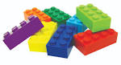

Task 2: 2D shapes
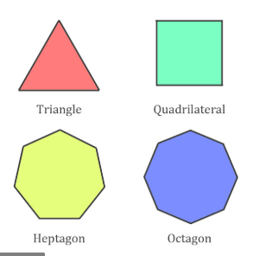
- A regular polygon has three or more sides that are all equal. Find and draw 3 regular polygons in your house or garden in the space on the next page.

- An irregular polygon has three or more sides that are all not the same. Find and draw 2 irregular polygons in your garden in the space below.

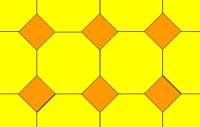
- Find and draw an example of a tessellation pattern in your house. (Hint: look at the bathroom tiles or curtains in your room)

- Find and draw an example of a shape with two parallel lines in your bathroom.

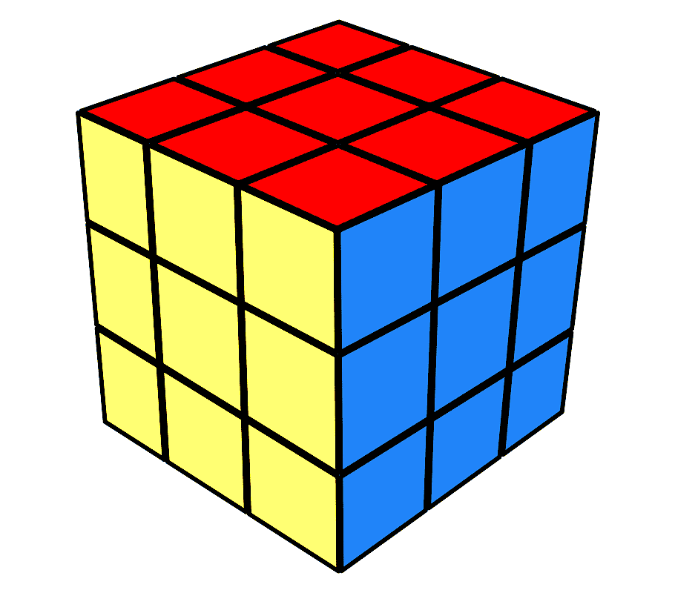
Task 3: 3D shapes

- Pick up your favourite book. How many faces, vertices and edges does your book have? (use the picture below to help you)

- Faces: _______
- Vertices: _______
- Edges: ______
- Look at your fridge. How many faces, vertices and edges does your fridge have? (use the picture below to help you)
Edge

- Faces: _______
- Vertices: ______
- Edges: ____
Vertex
Face
- a. Count and make a bar chart of the following shapes in your kitchen: cube, cylinder, cone, sphere, and hexagonal prism

20
19
18
17
16
15
14
13
12
11
10
No of shapes
9
8
7
6
5
4
3
2
1
cube cylinder cone hexagonal prism sphere
- How many more cubes are there than spheres?
- How many cones and cylinders are there combined?
_____________
- Which shape is most common? ______________
- Why do you think this is? _________________

