 | Monday | Tuesday | Wednesday | Thursday | Friday
Maths  Count out loud every day | Busy at Maths (big book) Page 94  Can you use lego/building blocks to copy the sum in the book.  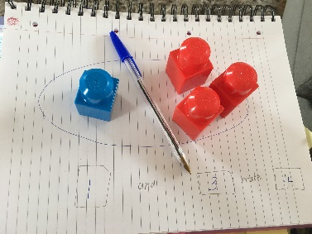 | Small Book page 22  Count. Add. Write. | Small Book page 23  Say the Nursery Rhyme together and order the pictures 1-3 | Small Book page 24  Practicing the Number 5 | Find 5 yellow, blue, green and orange things in your house.
English  Writing | Jolly Phonics Pupil Book 1  Page 47 (last page in book)  Try to read the sentence on your own and fill in the words that are missing. | Just Handwriting (big book) page 30 | Just Phonics (Big purple book) page 58 | Sounds Make Words (green book) page 33 | Just handwriting (big book) page 31
English  Reading | Read a book each day. Practice your sounds every day. Practice tricky words.  New Tricky Words this week to add to your small bag from your big bag: also, out, any | Read a book each day. Practice your sounds every day. Practice tricky words.  New Tricky Words this week to add to your small bag from your big bag: also, out, any | Read a book each day. Practice your sounds every day. Practice tricky words.  New Tricky Words this week to add to your small bag from your big bag: also, out, any | Read a book each day. Practice your sounds every day. Practice tricky words.  New Tricky Words this week to add to your small bag from your big bag: also, out, any | Read a book each day. Practice your sounds every day. Practice tricky words.  New Tricky Words this week to add to your small bag from your big bag: also, out, any
Rhyming & Dictation | Write 3 words that rhyme with: hair | Call out these words to your child and ask them to write them: pen hen den | Write 3 words that rhyme with: lock | Call out these words to your child and ask them to write them: stag book met | Write 3 words that rhyme with: star
Other | History:  Find a baby picture of yourself. How have you changed? What stayed the same? Discuss things that grow/do not grow. What can you do now that you could not before? What is good about getting bigger?  Draw 2 things that grow and 2 things that do not grow. | Geography:  Discuss the work and workplace of a doctor. Draw 3 things a doctor might use in their work. Can you label them? | Science: Hot & Cold  Discuss hot and cold food. What is your favourite hot food and your favourite cold food? How can you keep food cold? Which foods need to be kept cold? What happens when water gets very cold or very hot? How can you make water extremely hot? Name things in the house that can be hot to touch. | Religion:  Grow In Love page 36&37  In school we had heard the story of the loaves and fish. Can they retell the story? Colour the pictures. | PE:  Complete a home workout from YouTube.

