Hi all,
This week we are going to do things a little differently and include choices in your homework. I have included 3 activities that you can substitute for a days school work. This means that instead of schoolwork you can chose to do one of the activities.

Activity 1- Build a Log pile lodge in your garden.

Log pile lodge
Decaying wood is really important for wildlife. To make a log pile, simply collect small logs, large sticks and pieces of rotting wood. Pile them up in a damp, shady area of your garden, then stuff some dead leaves, straw or dried grass in the nooks and crannies to make it cosy.
Good for: centipedes, woodlice and beetles who like to burrow into decaying wood. Log piles may also attract birds, frogs and hedgehogs looking for a tasty snack!
Take a photo of you and your log pile and send it in to be included in this week’s activity pictures.

Activity 2- Build and paint a Crazy Caterpillar.
You will need:
Paint( markers or twistables will do if you have no paint)
Paint brush
Newspaper
Rounded stones

1. Paint your rocks.
Make sure that you put the newspaper under the rocks before you start. It's recommended that you paint them multiple colours, for fun. But you can certainly paint them all one colour if you like. Have fun! Be prepared to take some time on this part. You need to paint one side, let it dry, and then paint the other.

2. Draw the face on your caterpillar's "head".
3. Assemble the caterpillar after the paint has properly dried!
You can use glue if you get help but it might be nice to just line the stones up one after the other.
Place the caterpillar beside your Log pile Lodge if you have made one.
Take a photo. We would love to see your caterpillar!

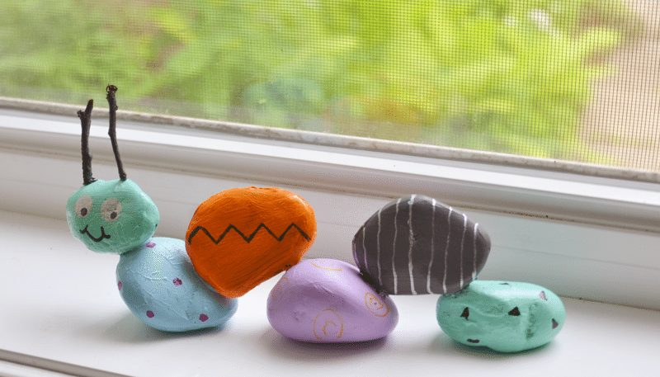

Activity 3-Draw the wildflowers in your garden.
Explore your garden and see what wildflowers you can find and how many you can name. Make a list of the wildflower names. How many did you find?

