5th May 2020

Hi Everyone,
I hope that you are all keeping well. Below is suggested work for this week. Try to get through this work by yourself if you can. You can always ask an adult for help if you there is something that you don’t understand.
Please get in touch with me if you need to ask me anything about your work. My email address is principalthomastown@gmail.com.

Ms. Donovan

English
Reading: Literacy Lift Off P176 - Cosmic. (Read the story aloud)
Vocabulary: Find out the meanings of these words from the story.
- Rumours
- Infinite
- Obviously
- Routine
- Manoeuvre
- Deny
- Technology
- Somersault
- Levitate
- Average
Write the words and their meanings into your copy.
Learn how to spell these words and ask someone to give you a spelling test later in the week.
Written Activities: Complete Activities A, B, C, D, E and F on pages 174 and 175. Write the answers into your copy.

Research: Activity F asks you to do some research on the Apollo 17 mission. Here is a useful website:
https://kids.kiddle.co/Apollo_17

Gaeilge
Bua na Cainte P152 - 156 (Sa Bhaile)

- P.152: Sa Ghairdín ar Chúl an Tí – Léigh an scéal os ard agus freagair na ceisteanna.
Bord éan (bird table)
Barra rotha (wheelbarrow)
Ag baint fiailí (picking weeds)
Seanchiteal (an old kettle)
Nead (nest)

- P153: An Seanchiteal: Abair an dán, scríobh an dán i do chóipleabhar agus tarraing pictúir.
Gan ghob (without a spout)
Gan chláirín (without a lid)
Ag bíogáil (chirping)

- P154: An Seomra Folctha – Bain úsaid as na focail sa phictúír agus déan cur síos ar an seomra folctha (use the vocabulary to describe the bathroom)

Freagair na ceisteanna i do chóipleabhar

- P155: Ciara sa Seomra Folctha – Léigh an scéal os ard agus freagair na ceisteanna.

- P156: An Nuacht agus Tuar na hAimsire – Léigh na scéalta os ard.

Foclóir Nua: Fiailí
Barra rotha
Spideog
Taos Fiacal
Sconna
Scáthán
Doirteal
Radaitheoir
Ráille
Tuáille

Learn the spellings of these words. Ask someone to give you a spelling test later in the week.

Maths (Rang 3)

Busy at Maths 3: Chapter 22: Length (P119 – P122)
Chapter 23: Multiplication and Division by 7 (P123 – P126)
A Quick Look Back 8: P127
Try all of these pages by yourself. Ask for some help if you need it. Ask an adult to check over your work when you are finished.
Practical Work: If you have a measuring tape at home then measure the length of different items around your house and garden. Estimate the answer before measuring. Remember that there are 100 centimetres in 1 metre.

Maths (Rang 4)
Busy at Maths 4: Chapter 24: Pattern (P122 – P124)
Chapter 25: Time 2 – Hours and Minutes

Remember: There are 60 minutes in one hour.
If you get 60 or more when you add the minutes, you must rename this as hours and minutes.
Example: 75 minutes = 1 hour and 15 minutes.
When subtracting, if you need to rename an hour as minutes, remember that one hour is equal to 60 minutes, not 100.
Example: 5 hours 25 minutes can be renamed as 4 hours and 85 minutes.

Try all of these pages by yourself. Ask for some help if you need it. Ask an adult to check over your work when you are finished.

Flower Pot Challenge
Now for the fun part!!
You are probably doing some gardening at home at the moment. You might be planting seeds or flowers in pots.
You can easily paint clay flower pots. You can also draw on them with markers.
Have you ever tried decorating your flower pots?
Have you ever tried to make a flower pot person?
The pictures on the next page might give you some fun ideas that you could try out at home this week.
If you would like to give this a go, then send me some photos of your flower pots when you are finished.
I will post your photos to the school Twitter account so that your classmates will be able to see them.
There are loads more ideas on Pinterest.
Are you willing to take part in the 3rd & 4th Class Flower Pot Challenge???????????????

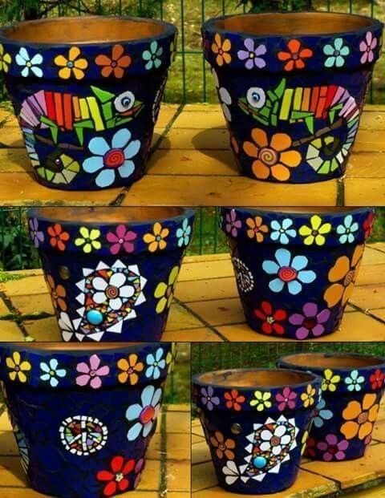

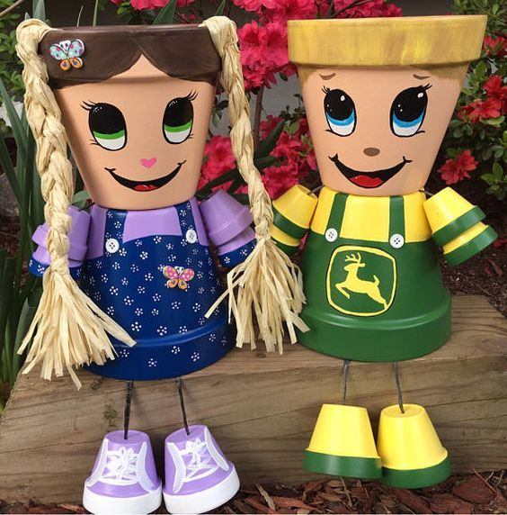 | 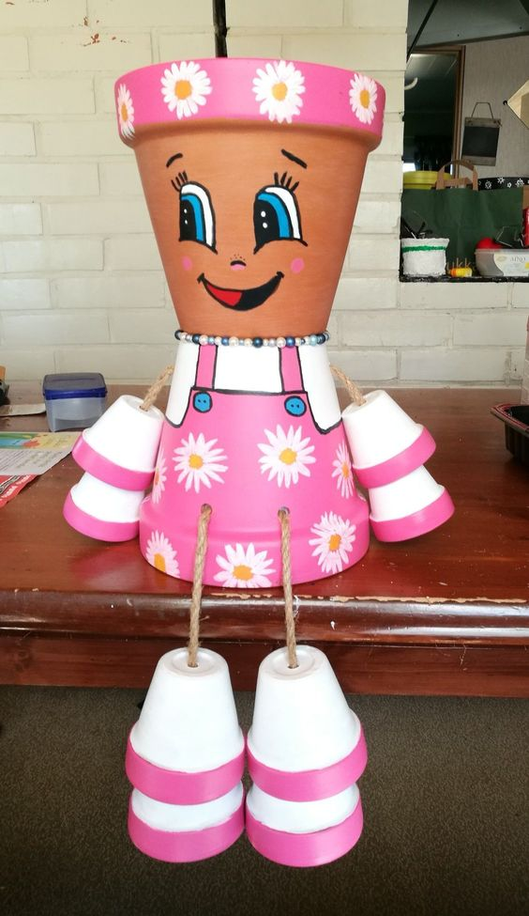
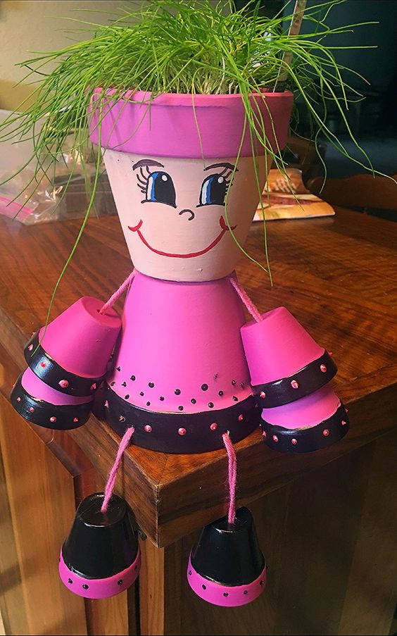 | 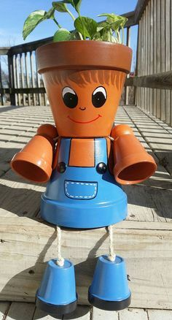

PS. If you are going to try a flower pot person, don’t worry about adding arms and legs (it looks tricky). Just do the head and the body and it will still look great. Enjoy!!

