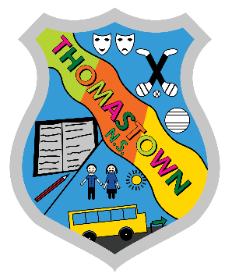

School Calendar 2020-2021

School will open on Monday 31st August 2020
2020 | 2021
October 2020 Mid Term Break  School will close from Monday 26th October to Friday 30th October inclusive  Christmas 2020  School will close on Tuesday 22nd December 2020 and will reopen on Wednesday 6th January 2021. | February 2021 Mid Term Break  School will be closed on Thursday 18th and Friday 19th February 2021.  St. Patrick’s Day  School will be closed on Wednesday 17th March 2021.  Easter 2021  School will close on Friday 26th March and will reopen on Monday 12th April 2021.  Bank Holidays  School will be closed on Monday 3rd May and Monday 7th June 2021.  Summer Holidays  School will close on Wednesday 23rd June 2021.

